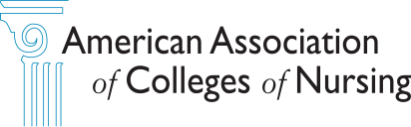 **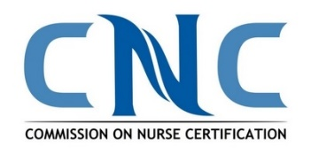  
  
The Clinical Nurse Leader (CNL®) Educator Award**

**Call for Award Applications**

The American Association of Colleges of Nursing (AACN) and the Commission on Nurse Certification (CNC) are now accepting nominations for the 2025 CNL Educator Award. This national award recognizes a CNL faculty member or education program director for innovative and outstanding preparation and advocacy of CNLs. In addition, the award promotes the contributions of the CNL faculty member in transforming nursing education and promoting innovation in both academia and practice. The 2025 recipient will be recognized during the opening session of the CNL Conference hosted by the International Clinical Nurse Leader Association, which will be held in Charlotte, NC, February 13-15, 2025.

**NOTE: The application deadline is December 9, 2024, 5:00 pm (ET).**

**Award:** The CNL Educator Award recipient will receive a complimentary registration to the 2025 ICNLA Conference, a commemorative award, a CNL lapel pin, and $500 for travel expenses. (For information about the ICNLA Conference, go to https://cnlassociation.org/upcoming-events/).

**Eligibility Criteria:** The candidate must be nominated by a nursing colleague, co-faculty member, dean, CNL graduate, or CNL student. (Previous nominations will be accepted but should be updated and permission from the nominee confirmed.) The candidate must meet the following criteria:

* Current CNL Certification
* Employed as a faculty member and/or program director for a CNL master’s or post-master’s CNL education program for a minimum of two years
* Demonstrate innovative pedagogy using a variety of teaching strategies and learning experiences that facilitate CNL student learning outcomes
* Provide examples of engagement in partnerships with practice to transform CNL education and patient care with sustainable outcomes
* Demonstrate professional leadership in developing and sustaining the CNL skill set through innovative partnerships
* Serve as a role model to bridge CNL education with practice by contributing professional education and practice environment
* Promote change and collaboration within the education and practice systems to improve the quality of patient care
* Advocate for the CNL skill set at the local, state, or national levels, to include publications and/or presentations

If selected, the recipient must be available to attend the 2025 ICNLA Conference and present a brief 5–10-minute presentation highlighting his/her experience, actions, and outcomes implementing and advancing CNL education and the CNL.

**Submission Requirements:**

The application must include a criteria statement/narrative no more than two pages that details how the candidate demonstrates the eligibility criteria and two letters of support from individuals other than the person submitting the application. These individuals may be from academia or practice and should describe their relationship with the CNL educator, length of time known, and how the nominee embodies the award criteria. The criteria statement/narrative and two letters of support should be submitted as attachments.

**Application Deadline and Review:** Applications must be received by AACN by **December 9, 2024, 5:00 pm (ET)**.

The application for the 2025 CNL Educator Award must include the completed application form, criteria statement/narrative and two letters of support. All materials must be submitted together. The completed application and letters of support should be submitted electronically to Bridget Bingle at [bbingle@aacnnursing.org](mailto:bbingle@aacnnursing.org).

A review panel (two members representing AACN and one member of the CNC Board of Commissioners) will consider all completed applications received by the deadline. The recipient will be selected based upon the information submitted describing how the nominee meets the eligibility criteria; preference will be given to the applicant who has demonstrated innovative and effective change for care delivery and CNL education. The recipient will be notified by Monday, December 16, 2024.

(*By submitting the application, all parties consent and authorize use of the narratives as well as future photos for promotional purposes. Excerpts from the application will be read during the award presentation at the CNL Summit. Descriptions may be included in a future database of CNL best practices. It is the responsibility of the individual submitting the application to obtain permission from the nominee prior to submitting the application.)*

**Questions?** Contact Lynn Gardner, CNC Director of Certification, at [lgardner@aacnnursing.org](mailto:lgardner@aacnnursing.org) or Dr. Joan Stanley, AACN’s Chief Academic Officer, at [jstanley@aacnnursing.org](mailto:jstanley@aacnnursing.org).

AACN and CNC reserve the right to not present the award in 2025 if it is determined that sufficient qualified applications are not received.

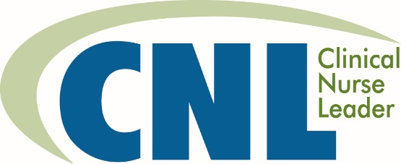 **EDUCATOR AWARD**

**APPLICATION**

**Part A**

**Nominator:** ______________

**Credentials:** ____________________________

**Title:** -__________________________________________

**Organization:** ____________________________

**Address:** _____________________

**City/State:** , **Zip:** _____________________

**Telephone:** ______________

**Email:** ______________

**Relationship to candidate (check one):**

Colleague/Co-worker  Supervisor  CNL graduate  CNL Student  Other:

Signature: _____ Date: _______

**I Accept** (By selecting the “I Accept” button, you are signing this application electronically. You agree your electronic signature is the legal equivalent of your manual signature on this application.)

**Part B**

**Nominee:** _______

**Credentials:** _______

**Title:** ______________

**School:**  ______________

**Address:** ______________

**City/State:** , ____ **Zip:** ______________

**Telephone:** _______

**Email:** _____________________

**Length of time in position as a CNL faculty member or program director (can be cumulative):** _____________

**Part C – Criteria Statement/Narrative** (two-page limit)

1. **How has the candidate demonstrated innovation in designing CNL curriculum, learning experiences that facilitate CNL development, and/or practice opportunities?** (Specific examples of outcomes should be included.)
2. **How has the candidate demonstrated leadership and contributed to the creation and sustainment of academic–practice partnerships that promote CNL education and practice?**
3. **How has the candidate advocated for the CNL skill set?**
4. **Additional information**

**Part D – Letters of Support** (Describe the relationship with the CNL faculty member, length of time known, and how the nominee embodies the award criteria. **Letters of support must accompany the application – attach letters**.)

**Recommended by:**  _____________________

**Credentials:** _______

**Title:** _____________________

**Organization:** ______________

**Address:** ______________

**City/State:** ____ **Zip:** ______________

**Telephone:** _______

**Email:** _____________________

**Recommended by:** ____________________________

**Credentials:** ____________________________

**Title:** ___________________________________

**Organization:** ___________________________________

**Address:** ______________

**City/State:** ____ **Zip:** _____________________

**Telephone:**

### **Email:** _______________________________________________________________________

**Application Deadline:** December 9, 2024, COB 5 p.m. ET

**Send application to:** Bridget Bingle at [bbingle@aacnnursing.org](mailto:bbingle@aacnnursing.org)