Safety Nurse Clinical Learning Activity
INSTRUCTOR’S COPY
Instructions: You are assigned as the unit “Safety Nurse” during clinical this week.
Please complete the pre-clinical assignment below.
Pre-clinical assignment: Locate resources to answer the questions below.

- Define the following terms:

  - Culture of Safety: From the employee perspective, this is the practice of promoting safe nursing care. The focus on how one’s actions can impact the larger system. Nursing values and actions are important to promoting a safe culture. There is also a focus on holding others accountable when they deviate from standard practice.

  - Just Culture: Like a culture of safety, but often from a larger perspective. Errors are acknowledged and attributed to faults in the broader healthcare delivery system. This also relates to how nurses engage with each other and attribute fault. A just culture aims to protect clients and change practices to prevent systemic harm. This extends to the idea of treating others with respect and kindness. Understanding others’ perspectives can help promote a just culture.

  - High-Reliability Organizations: This is a trait of organizations focusing on continuous quality improvement. These organizations often manage their metrics extremely well and strive for ways to innovate on the current level of care provided. Often, these principles are exemplified in the organization’s mission, vision, and values.

- Identify the factors that create a culture of safety:
There is a plethora of factors that promote a culture of safety. However, critical components include having staff distinguish safe from unsafe actions. Moreover, the organization must adopt systems promoting a safe working culture. These include but are not limited to staffing, technology, training, and other activities that can empower employees to do the right thing. Finally, this impaired process needs to be identified and discouraged when deviation occurs.

- Identify your role in sustaining a just culture reflecting civility and respect:
Nurses need to create the culture that they wish to work in. As critical members of the care team, the registered nurse can influence the actions of others directly or indirectly. An extension of this idea is treating our coworkers and subordinates with respect. Due to the caring nature of the profession, nurses are often left emotionally exhausted. Being cognizant of the emotions and perspectives of others is how a nurse can promote a just culture. In a grander sense, nurses must promote systems supporting collaboration and kindness. When systems burden the processes of care team members, this creates a high-stress culture that is not indicative of patient-centered care.

- Identify the National Safety and Quality Standards (National Patient Safety Goals) that guide nursing practice on the unit:
There are specific items or events that hospitals are penalized for if they occur. Often coinciding with quality metrics, hospitals are responsible for reporting their data to governing bodies. Each unit has a particular risk for these never events. However, it would be good to cross-check the PSI-90 metrics gathered by the Centers for Medicare & Medicaid Services with the clinical location.

- Locate National Quality Metrics on the internet. Identify metrics that guide nursing practice on the unit you are assigned. For example, medical/surgical units often look at metrics for preventing Congestive Heart Failure readmission.
Commonly, large governmental organizations collect hospital indicators and metrics. These affect ranking and reimbursements. CMS, for example, uses the PSI 90 to talk, record, and measure unsafe conditions. Some of these adverse events are infections (CAUTI, CLABSI, CDIF), falls with major injuries, surgical site infections, pressure injuries, and readmissions (heart failure, and COPD). Other reporting bodies measure specific hospital metrics for local and regional comparisons. There are some similarities among these reporting tools, and all try to measure the quality of the care provided accurately.

- Read an article and identify the basic principles to reduce risk of harm (harm reduction). Some potential articles to use are as follows:
- Fox, M. D, Bump, G. M., Butler, G. A., Chen, L., & Buchert, A. R (2021). Making Residents Part of the Safety Culture: Improving Error Reporting and Reducing Harms. Journal of Patient Safety, 17(5), e373-e377. https://doi.org/10.1097/PTS.0000000000000344
- Domdera, J. (2023). Patient Safety Tools for Primary Care. Family Practice Management, 30(2), 24–28.
- https://www.ncbi.nlm.nih.gov/pmc/articles/PMC7142993/ a systematic review of nursing role in patient safety

- Using the activity list below, identify two evidence-based interventions that could be applied to prevent the errors you will be monitoring.
N/A

During your clinical experience (day of clinical as the “Safety Nurse,” please complete the following: (Can be discussed in pre-conference)
- If accessible, review and interpret trends/benchmarks and unit outcome data that inform practice on your unit.
Some clinical locations have their metrics shown on the unit. You can confirm with the floor managers who can provide unit-specific data. If unavailable, please use the Integrated Leadership Dashboard (from a YNHHS computer) for hospital-specific data https://ild.ynhh.org/#/dashboard. The student will identify trends and discuss why specific metrics may be out of a desired range.
(Please see snapshot 1A for what the dashboard looks like.)

- Identify the nurse’s role within the interprofessional team in promoting safety and preventing errors and near misses (example Participate in Huddle).
The nurse is a critical part of the care team. They have more hours to spend with the patient and have the knowledge to interpret the care provided. The nurse serves as a coordinator and team leader for their assigned patients. Additionally, it is the nurse’s responsibility to communicate observations to other pertinent team members. From a clinical perspective, the nurse must comprehend why care is provided and direct ancillary services accordingly. When this chain of responsibility breaks down, patients are more at risk for harm and near-miss events.

- Identify a process used to understand the causes of errors on this unit (examples: fall debriefing tool, CLABSI/CAUTI debriefing tool, blood transfusion tool, medication administration errors, etc.)
Each unit has tools to report safety events and potential harm for a case review. Some tools are electronic, while others are paper. The student will work with staff to identify where these tools are located. Please see below for directions on where the appropriate review tools are housed.

- Post-Fall Debriefing Tool: See your practice site for specific links.
- CAUTI Case Review: This form reviewed by managers and infection prevention. See your practice site for specific links.
- CLABSI Case Review: This form is reviewed by managers and infection prevention. See your practice site for specific links.
- Blood Transfusion reaction/Medication errors- see your practice site for specific links.

- Identify the actual and potential levels of risks to providers on the unit (example Brøset Violence Checklist and CAM non-ICU). Identify a low, medium, and high-risk score.
There are many tools the system uses to determine if a patient is a potential risk to staff. The nurse’s role is to navigate these situations and determine the best way to interact with these clients. The student will review and understand the Brøset Violence Checklist and CAM non-ICU assessment and identify ways to manage a high-, medium-, and low-risk patient.

- Identify measures to prevent workplace violence and injury on the unit. (Such as injury—back injuries related to lifting patients; violence could be related to family members or patients becoming violent; CPI training—identify signs of distress and anxiety; code alert system)
Many environmental hazards can pose injury to nurses. The student nurse will identify items or tasks that can put staff at risk. If time allows, the professor can show the CPI training offered by the organization under LMS training. To get there, log onto Learning Management Systems and search CPI. This class and its associated subsections can help the student identify patient anxieties. Learning Management (certpointsystems.com)
(See snapshot 5A for CPI training page)

- Identify any policies for preventing violence and injury used at the facility.
The organization offers policy guidance on how to manage combative patients. Additionally, a care pathway outlines how to manage these procedures. Finally, the organization has a Workplace Violence Committee that meets monthly. Please see below for specific directions to access information:

- Policy: Look up the policy tab on the corporate internet. Search for ‘Workplace Violence’; this should be the first result in the list. Policy Manager - MCN Healthcare (ellucid.com)
(See snapshot 6A for the title of the document)

- Care pathway: On the corporate internet, click the ‘resource’ tab, then ‘Care Signature pathways,’ then “Adult Inpatient Pathways.” Finally, search for ‘Social Drivers of Health Evaluation and Resources: Adult Ambulatory and Inpatient‘ AgileMD | Social Drivers of Health Evaluation and Resources: Adult Ambulatory and Inpatient

- Workplace Violence Committee Homepage: Search for workplace violence on the corporate internet search tool. Then, look for your local workplace violence committee library and view the minutes. WPV Meeting ​​Minutes - All Documents (ynhh.org)
(See snapshot 6B for the title page of this committee)

- Identify communication pathways for reporting, monitoring, and evaluating identified safety concerns, occurrences, and harm/injury events.

- Identify two to three environmental safety issues that you observed being addressed during your shift.

- Identify one potential environmental safety issue that requires communication/advocacy by you to the charge RN or other team member.

- Pharmacy Safety Check: Identify one to three procedures used on the unit for safe medication delivery, storage, and monitoring.

- Population Safety Check: Consider any safety issues specific to the patient’s age, developmental stage, cognitive ability, and diagnosis.
  - Identify at least two nursing care interventions that will promote safety with the patient population on your unit.

During the clinical day, please participate in quality and safety initiatives on the unit. The following are examples of initiatives that may be occurring on your unit.

Activity: | Assessments/findings: | Follow- up interventions/corrective action if applicable:
Unit Checks – General Safety Activities
Check the code carts.  Examples of what should be checked: locked, sign out sheet, defibrillator checked daily, oxygen tank full, check for expired medications, defibrillator pads present and not opened) | At YNHHS, code cart checklists should be on or directly above the code cart. This ensures that the defibrillator is checked, the expiration date is appropriate, and the cart lock is in place. The student will observe that previous dates are filed appropriately. | Unfortunately, it is illegal to back chart skipped/missed code cart assessments. If the student notices that the current date is not filed, they will contact the charge nurse and inform them of the variance.
Handwashing surveillance:  Observe your peers for handwashing—follow up as needed.  Target--Observe 20 handwashing occurrences. If you observe the nurse washing before going into and out of the room, that is considered two occurrences. | At YNHHS, an encounter is defined as entering a patient’s room to provide services. Each encounter has an entry and an exit; the student should observe both opportunities. | Suppose the student sees someone who is non-compliant with hand hygiene. In that case, they will provide a gentle reminder and explain the variance to the non-compliant staff at a convenient opportunity.
Check barcoding and Workstations on Wheels (WOWs):  Observe the use of the barcoding process in medication administration and labs. Discard ancillary banding. Ensure ancillary bands are not taped to the doors or under the WOWs. Observe the WOWs—cleanliness, free of patient information, HIPPA compliant.  When not in use, computer screens are turned off. | The student will observe a medication pass during this experience.  Sometimes, nurses leave barcoding for medications like insulin or certain inhalers tapped to the WOW. Students will round the unit and ensure that the computers are free of these materials and are clean in appearance. Additionally, the student will note any unclean computers as well. Finally, screens not in use should be turned off. | Students will perform the observations described. Additionally, the student will identify and dispose of any pertinent items from the WOW. If the WOW is unkept, the student will clean the WOW with the appropriate unit-specific cleaner.
Observe one medication administration, noting how many interruptions occur | Medication administration may be a fragmented process. The student will observe one care encounter where medication is provided to the patient and note how often care is interrupted. | If glaring variances occur, the student will assist in real-time to provide support and corrective action. However, the intent is to count interruptions. This is so the student knows that interruptions can occur during inopportune times.
Patient-protected information is in appropriate areas.  Round on the unit and look for variances. | Coinciding with the workstation checks, sometimes providers leave patient information unprotected in the care areas. The student will round the unit and look for material that may contain sensitive information. | If students find any information in question, they will provide it to their preceptor. An honest effort will be made to track down the owner of the information. If undeterminable and deemed nonimportant, the information will be disposed of in the proper receptacle.
Confirm with the Patient Care Assistants which patients need turning due to skin breakdown risk (Braden Scores) and mobility score (AMPAC).  Patients with self-harm/safety risk: observe the procedure for monitoring every 15 or 30 minutes, observe documentation for the use of any patient restraint device. (medical/psych) | The students will connect with the Patient Care Assistants of the unit and assist with the mobility of appropriate patients. | Outside of physically assisting the Patient Care Assistants, the student will identify Braden Scores and AMPAC that correlate with the physical condition. Finally, students will document the mobility assistance provided.
If possible, attend appropriate floor meetings addressing that safety/quality such as Huddles, discharge rounds, safety rounds, etc. | The student will attend huddles and applicable safety rounds to gain a deeper understanding of the patient population and supportive care needs. | The student will observe these meetings. No additional follow-up action is required.
Room Checks – These can be the same five patients for each criterion
Check five IV sites and/or central lines (look for expiration, redness, infiltration, leaking, and pain). Check the tubing and make sure the dates are on the tubing. | The student will round on five patients with a peripheral catheter and/or central line. The student will visualize that the catheter looks appropriate and discard any outdated tubing. | If a variance occurs, the student will confirm an appropriate plan of action with the charge nurse or preceptor. The student will discard used tubing in the appropriate disposal areas.
Assess five patients, identifying their fall risk. If applicable, confirm with the nurse regarding the availability of a bed alarm. | The students will observe patient criteria in coordination with the current fall program: ‘Fall-TIPS’. | If applicable, the student will confirm with the covering nurse and ensure the appropriate bed alarm is in place.
Pick five rooms and ensure the room has an oxygen flow meter and an appropriate connection | The student will round on five selected patients and ensure that the room can provide oxygen support. | If the room does not have the appropriate flow meter and connection device, the student will connect with the charge nurse or preceptor to find appropriate resources.
Check five patients and ensure they have appropriate identification and alert bracelets intact.  Examples of alert bracelets: allergy, DNR/DNI, fall risk, fistula alert/ mastectomy, and no blood products | There are several different types of identification bracelets. The student will round on five patients and ensure that they are wearing their appropriate wristbands. There is some variation here depending on where the clinical is occurring. | If the student identifies a patient without the appropriate wristband, they will confirm their findings with the preceptor or charge nurse and correct the variance with the appropriate support.
Check five patients and ensure that call bells and appropriate side rails are within place. | The student will round on five patients of choice and ensure that their call bell is in place. Concerning side rails, the student will confirm with the covering RN on what is deemed appropriate for each patient. | If the student finds that the call bell is out of reach and the patient cannot acquire it, they will move it to the appropriate location and note the number of occurrences. For side rails, the student will ensure that appropriate side rails are active. The student will contact the covering nurse or instructor with any questions about patient safety.
Other: | Any other safety concerns of note are documented here. | Corrective actions were taken by students in collaboration with preceptors to mitigate harm.
Environmental Checks:
Identify any need for environmental modifications to ensure patient and staff safety which may include managing spills, broken equipment or furniture, presence of covered electrical outlets, locked door policy on the unit, badge/key access, elimination of ligature risks for suicidal or risk for harm patient (e.g., IV tubing, belts, shower curtains, telephone cords), or blocked access to exits.

Please note any “Good Catches”: ______________________
- For those who do not know, Great Catches have the potential to cause harm if not corrected. Though uncommon, students do often find variances or abnormalities that can be considered Great Catches. It is important to highlight these effective observations and provide feedback if necessary.

Post-conference presentation – The student is expected to speak on these points during the post-conference. Feel free to direct the conversation as needed.
Guiding questions:
- Give a summary of your experience as a Safety Nurse.
- What did you learn from this experience?
- How will you apply what you learned today to your clinical practice?
- Is there anything else you would like to discuss?
- What did you do with your findings?

Reflection – This will take the place of the student’s weekly reflection.
- What are some unsafe conditions, near misses, or errors you think can be reduced on the unit and how did you improve the conditions?
- How would you incorporate what you learned into practice?
- What additional safety knowledge or skills would you identify necessary to be effective as a future nurse in practice?

SNAPSHOTS
- 1A – Top of integrated leadership dashboard.
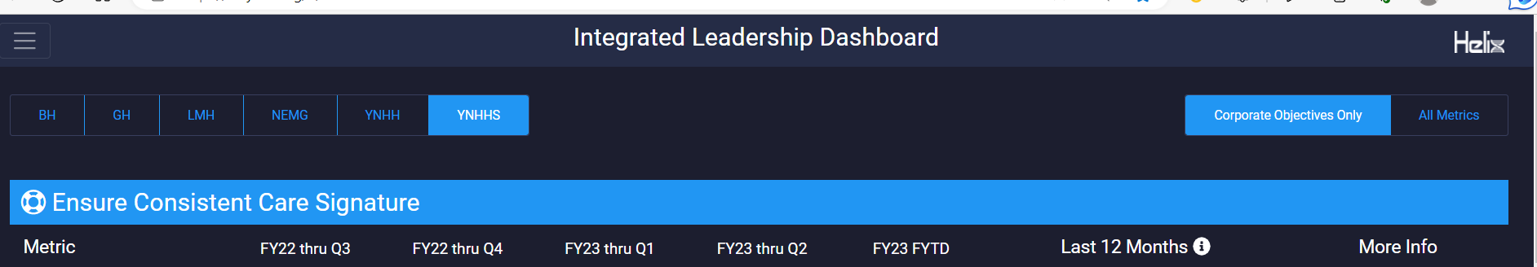

- 3A – Top of post fall debriefing tool
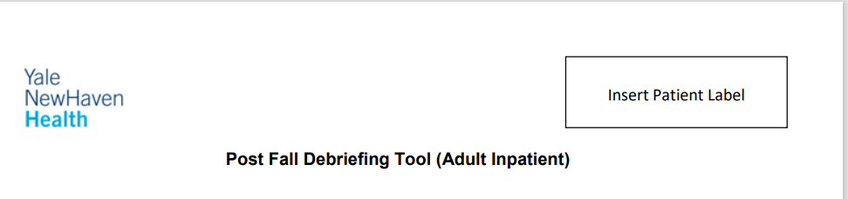

- 3B – CAUTI review Page
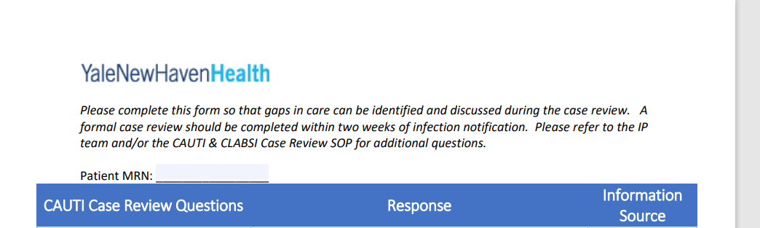

3C- CLABSI review page
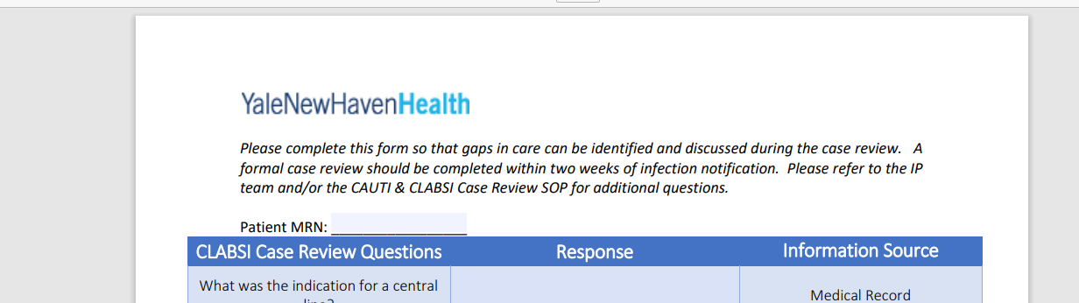

- 3D- Icons for blood transfusion reaction and Improper medication administration in RL solutions.
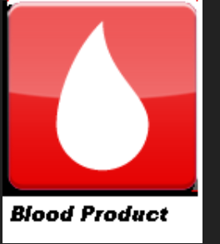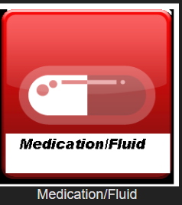

- 5A – CPI training page on LMS
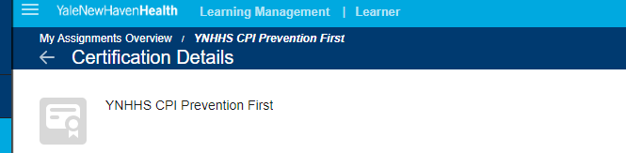

- 6A- Workplace violence policy
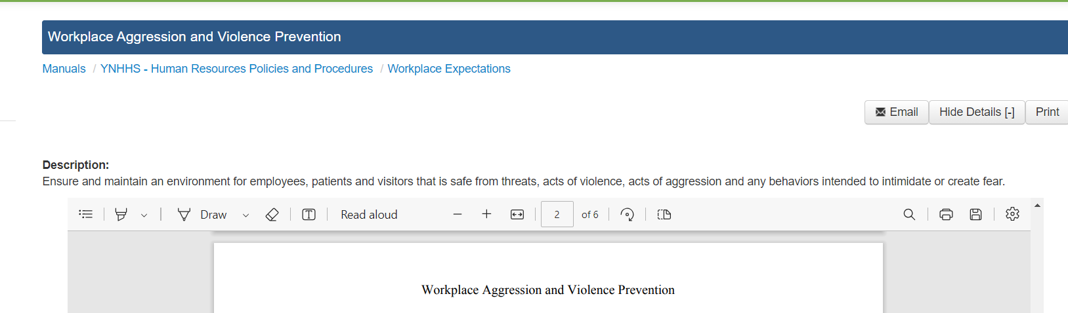

- 6B – Workplace violence committee home page
